**Server less hosting**

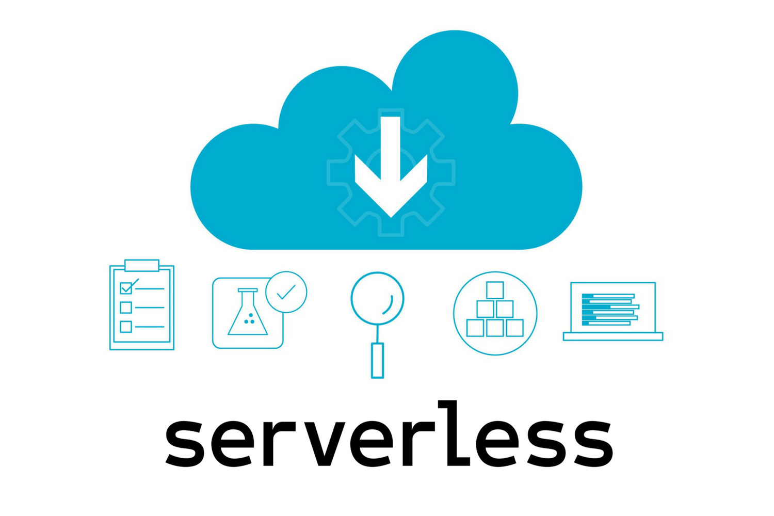

Server less is a cloud-native development methodology that enables developers to create and execute apps without having to worry about managing servers.

Servers are still there in server less, but they are separated from the app development process. The normal job of establishing, maintaining, and scaling the server infrastructure is handled by a cloud provider. For deployment, developers can simply wrap their code in containers.

Developers all over the world spend endless hours coding to solve business problems. Then it's up to the operations teams to figure out how to get code to run and then. the programs to run smoothly is a never-ending chore.

Serverless computing, on the other hand, has grown in popularity as a logical extension of this method. You don't need to know anything about the OS or hardware on which your code will execute if you use the serverless computing strategy. It's because your service provider will handle everything.

Do you want to learn more about serverless computing, which has gotten a lot of attention in the IT world? Let's take a closer look at the specifics of serverless computing so you can gain a better understanding of the situation.

**What is serverless computing?**

End-users benefit from serverless computing since it is a cost-effective way to deliver backend services. It's a cloud architecture that allows companies to delegate most of their operational obligations to third-party service providers.

A serverless architecture allows companies to build and deliver applications without having to worry about the infrastructure.

The serverless paradigm is a fantastic way to execute code on the cloud. The cloud provider allocates and changes the users for the storage and computer resources required to execute a given piece of code under this cloud execution model.

Although servers are used throughout the process, the service providers are responsible for their upkeep and provisioning. Users do not need to be concerned about any of these issues.

Those who wished to create a web application in the early days of the internet had to own and manage the physical hardware required to run a server.

This was a time-consuming and costly project. Cloud, on the other hand, arose from the revolutions in the IT field with the primary goal of providing customers with ease and comfort in the process of managing application infrastructure or servers.

However, serverless computing at the time was all about renting space on fixed server units. However, most firms used to overdo this to ensure that a surge in activity or traffic did not surpass their services' monthly limit. This is due to the fact that it may cause their applications to malfunction. However, it is evident that much of the rented server capacity was squandered more frequently.

However, when we talk about serverless architectures nowadays, we're referring to BaaS and FaaS solutions. Businesses must build code that exclusively addresses their business logic and then submit it to a provider.

The provider, on the other hand, will handle all container management, hardware provisioning, and virtual machine management, as well as duties like multithreading that are typically included into application code.

Serverless functions are frequently event driven, which means that the code is only executed when prompted by a request. Any company that uses serverless computing will be charged based on their calculations.

There is no need to reserve or pay for a specific quantity of bandwidth or number of servers. Because the serverless computing service is self-scaling, this is the case.

**Benefits of serverless hosting**

There are numerous benefits to becoming serverless, whether you're building a small real-time chat application or a corporate program. We've compiled a summary of some of the advantages of becoming serverless. So that you can learn more about the reasons for this.